*Student: Melis Kilic*

**Histograms**

**H-1. Histograms of artificial images**

clearvars;

close all;

clc;

% Create 256x256 images with:

% a) All pixels with value 0

all_zero = zeros(256,256);

% b) All pixels with value 255

all_255 = 255 * ones(256,256);

% c) Left half of the image with values 0 and the right half with values 255

left_half_zero = zeros(256,256);

left_half_zero (: , 1 : 256/2) = 255;

% d) Random image with pixels values from uniform distribution between 0 and 255

% (use function rand)

random_image = uint8 (255 * rand(255,255));

% e) With fluently changing grayscale from 0 (left side of the image) to 255

% (right side of the image). To the input image use matrix multiplication of

% column vector with ones with row vector [0:255].

gradient_vector = (0:255)';

gradient_image = uint8(gradient_vector * ones(1,256));

% When displaying images with imshow, either convert them to uint8 using

% Matlab command uint8(…) or usescaling: imshow(…, []).

figure('position', [100, 100, 1400, 500]);

subplot(2,5,1);

imshow(all_zero, []);

title('All Values is Zero (a)');

subplot(2,5,2);

imshow(all_255, []);

title('All Values is 255 (b)');

subplot(2,5,3);

imshow(left_half_zero, []);

title('Left Half is Zero (c)');

subplot(2,5,4);

imshow(random_image, []);

title('Random Image (d)');

subplot(2,5,5);

imshow(gradient_image, []);

title('Gradient Image (e)');

% Then calculate them using histogram(I, 0:256), where I is the image and

% the second argument are bin edges.

subplot(2,5,6);

histogram(all_zero(:), 0:255);

title('Histogram (a)');

subplot(2,5,7);

histogram(all_255(:), 0:255);

title('Histogram (b)');

subplot(2,5,8);

histogram(left_half_zero(:), 0:255);

title('Histogram (c)');

subplot(2,5,9);

histogram(random_image(:), 0:255);

title('Histogram (d)');

subplot(2,5,10);

histogram(gradient_image(:), 0:255);

title('Histogram (e)');

**Result of the code:**

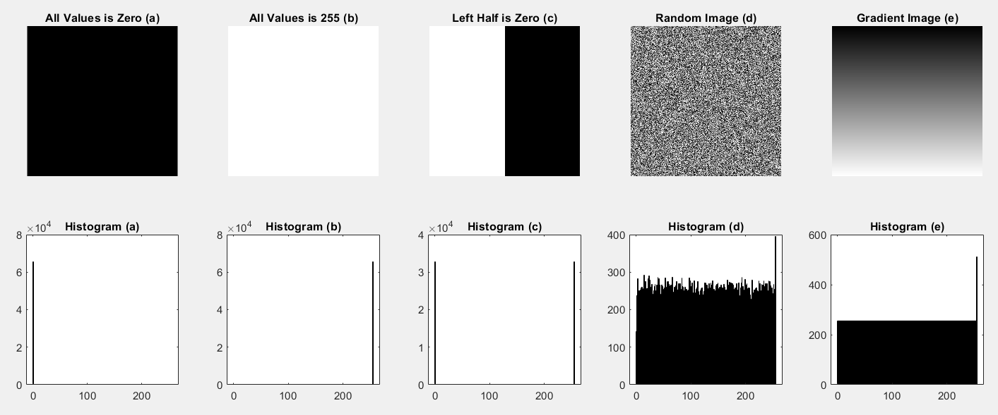

**H-2. Histograms of greyscale images with different brightness and contrast**

clearvars;

close all;

clc;

% Open baboon.bmp and convert to grayscale.

image = imread('baboon.bmp');

grayscale_image = rgb2gray(image);

% Create versions of the original image with different grayscale and contrast:

% G – original image in grayscale

g = grayscale_image;

% G1 – values of all pixels increased by 70

g1 = g +70;

% G2 – values of all pixels decreased by 70

g2 = g -70;

% G3 – increased contrast, e.g. G3=2*G

g3 = 2 * g;

% G4 – decreased contrast, G4=0.5*G

g4 = 0.5 * g;

% Display all images and their histograms in subplots:

figure('position', [100, 100, 1400, 500]);

subplot(2,5,1);

imshow(g, []);

title('G');

subplot(2,5,2);

imshow(g1, []);

title('G1');

subplot(2,5,3);

imshow(g2, []);

title('G2');

subplot(2,5,4);

imshow(g3, []);

title('G3');

subplot(2,5,5);

imshow(g4, []);

title('G4');

% ----------------------------------------

subplot(2,5,6);

histogram(g(:), 0:255);

title('Histogram (G)');

subplot(2,5,7);

histogram(g1(:), 0:255);

title('Histogram (G1)');

subplot(2,5,8);

histogram(g2(:), 0:255);

title('Histogram (G2)');

subplot(2,5,9);

histogram(g3(:), 0:255);

title('Histogram (G3)');

subplot(2,5,10);

histogram(g4(:), 0:255);

title('Histogram (G4)');

**Result of the code:**

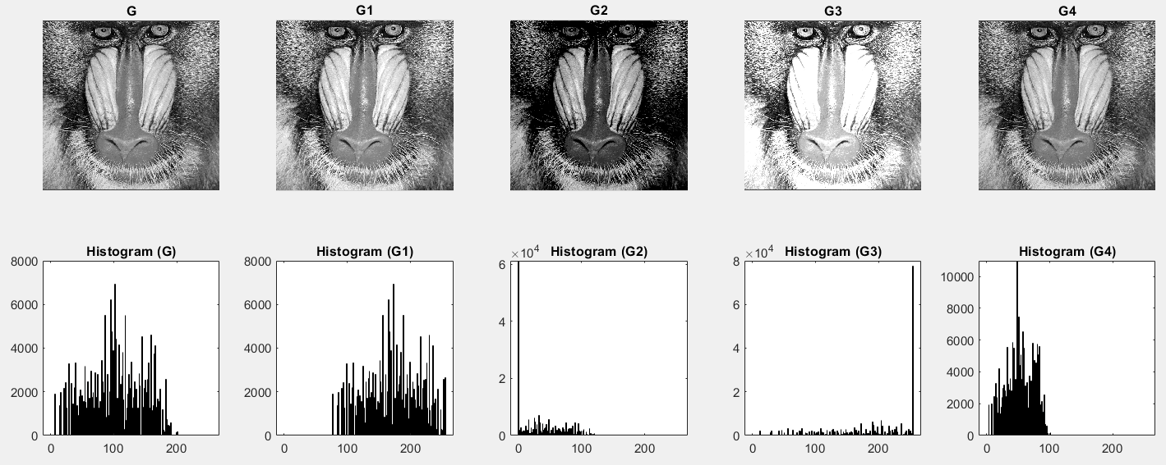

**H-3. Histogram stretching**

clearvars;

close all;

clc;

% Refer to the documentation and implement histogram stretching for the hist1.bmp image.

image = imread('hist1.bmp');

stretched_image = imadjust(image);

% Display the result of the operation in subplots:

figure('position', [100, 100, 700, 500]);

subplot(2,2,1);

imshow(image, []);

title('Original Image');

subplot(2,2,2);

imshow(stretched_image, []);

title('Image After Histogram Stretching');

subplot(2,2,3);

histogram(image(:), 0:255);

title('Histogram of The Original Image');

subplot(2,2,4);

histogram(stretched_image(:), 0:255);

title('Histogram After Stretching');

**Result of the code:**

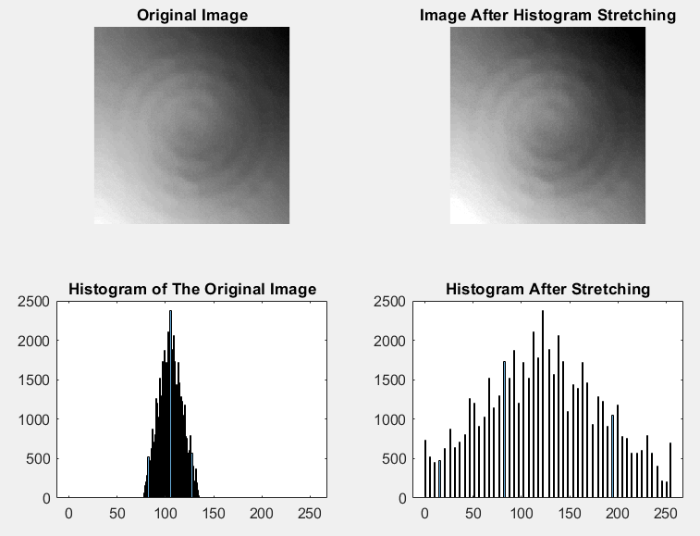

**H-4. Histogram equalization**

clearvars;

close all;

clc;

% Determine the cumulative histogram for the hist1.bmp image. The imhist

% function returns vectors describing the histogram (counts and corresponding

% brightness levels): [H, x] = imhist (I, n).

image = imread('hist1.bmp');

[H, x] = imhist(image, 256);

% For the calculation of the cumulative histogram use the cumsum function.

cumulative_hist = cumsum(H);

% Implementing the histogram equalization algorithm

I = imread('hist1.bmp');

[H, x] = imhist(I, 256);

% Rescaling

maxCumHist = max(cumulative_hist);

scaledCumHist = (255 * cumulative_hist) / maxCumHist;

% LUT transform

lut = uint8(scaledCumHist);

equalizedImage = intlut(I, lut);

[H_equalized, x_equalized] = imhist(equalizedImage, 256);

cumulative_hist_equalized = cumsum(H_equalized);

% Display the results

figure('position', [100, 100, 1200, 500]);

subplot(2, 3, 1);

imshow(I);

title('Original Image');

subplot(2, 3, 2);

bar(x, H);

title('Histogram of the Original Image');

subplot(2, 3, 3);

plot(x, cumulative_hist);

title('Cumulative Histogram of the Original Image');

subplot(2, 3, 4);

imshow(equalizedImage);

title('Equalized Image');

subplot(2, 3, 5);

bar(x_equalized, H_equalized);

title('Histogram of Equalized Image');

subplot(2, 3, 6);

plot(x_equalized, cumulative_hist_equalized);

title('Cumulative Histogram of Equalized Image');

%------------------------------------------------------

originalImage = imread('hist2.bmp');

% Histogram stretching

stretchedImage = imadjust(originalImage);

% Histogram equalization

equalizedImageHisteq = histeq(originalImage);

% Adaptive histogram equalization

equalizedImageAdapthisteq = adapthisteq(originalImage);

% Display

figure('position', [100, 100, 1400, 400]);

subplot(1, 4, 1);

imshow(originalImage);

title('Original hist2 Image');

subplot(1, 4, 2);

imshow(stretchedImage);

title('Image after Histogram Stretching');

subplot(1, 4, 3);

imshow(equalizedImageHisteq);

title('Image after Histogram Equalization');

subplot(1, 4, 4);

imshow(equalizedImageAdapthisteq);

title('Image after Adaptive Equalization');

**Result of the code:**

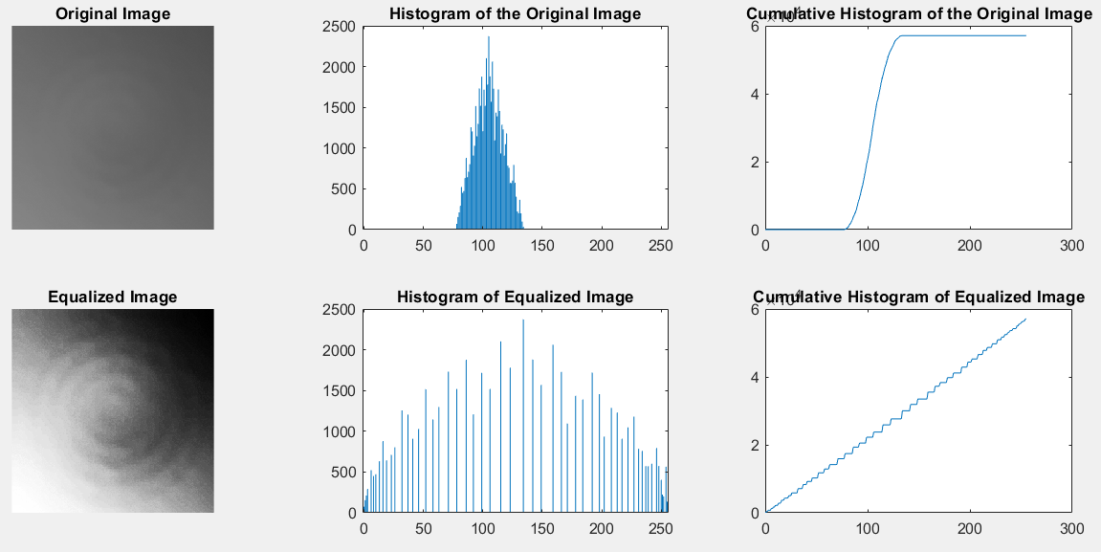

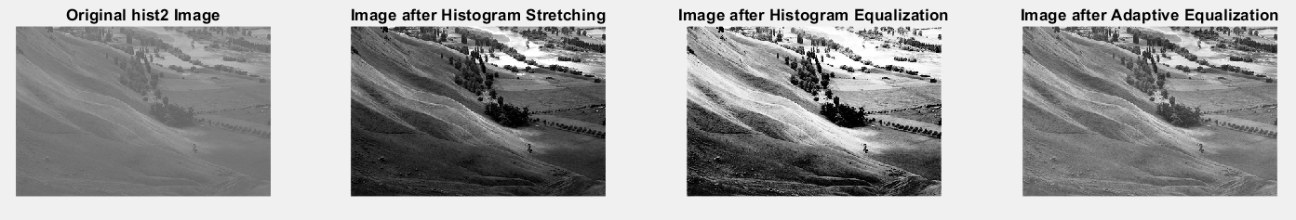

**H-5. Histogram matching**

clearvars;

close all;

clc;

phobos = imread('phobos.bmp');

figure('position', [50, 100, 1400, 650]);

subplot(2, 5, 1);

imshow(phobos);

title('Original Phobos Image');

phobos_stretched = imadjust(phobos);

subplot(2, 5, 2);

imshow(phobos_stretched);

title('After Histogram Stretching');

phobos_he = histeq(phobos);

subplot(2, 5, 3);

imshow(phobos_he);

title('After Histogram Equalization (HE)');

phobos_clahe = adapthisteq(phobos);

subplot(2, 5, 4);

imshow(phobos_clahe);

title('After Adaptive Equalization');

load desiredHistogram;

phobos_matched = histeq(phobos, desiredHistogram);

subplot(2, 5, 5);

imshow(phobos_matched);

title('After Histogram Matching (HM)');

% Calculate and display histograms for all images

subplot(2, 5, 6);

imhist(phobos);

title('Histogram');

subplot(2, 5, 7);

imhist(phobos_stretched);

title('Histogram');

subplot(2, 5, 8);

imhist(phobos_he);

title('Histogram');

subplot(2, 5, 9);

imhist(phobos_clahe);

title('Histogram');

subplot(2, 5, 10);

imhist(phobos_matched);

title('Histogram');

**Result of the code:**

